Verify Environment Access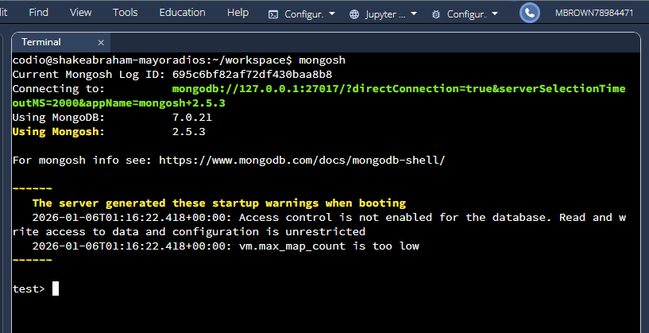
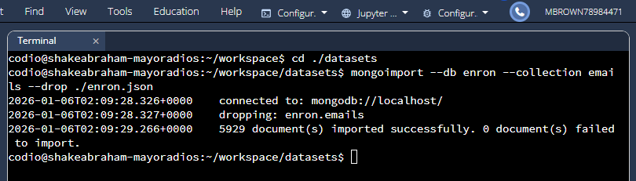

Mongo Shell Commands: Retrieve Document 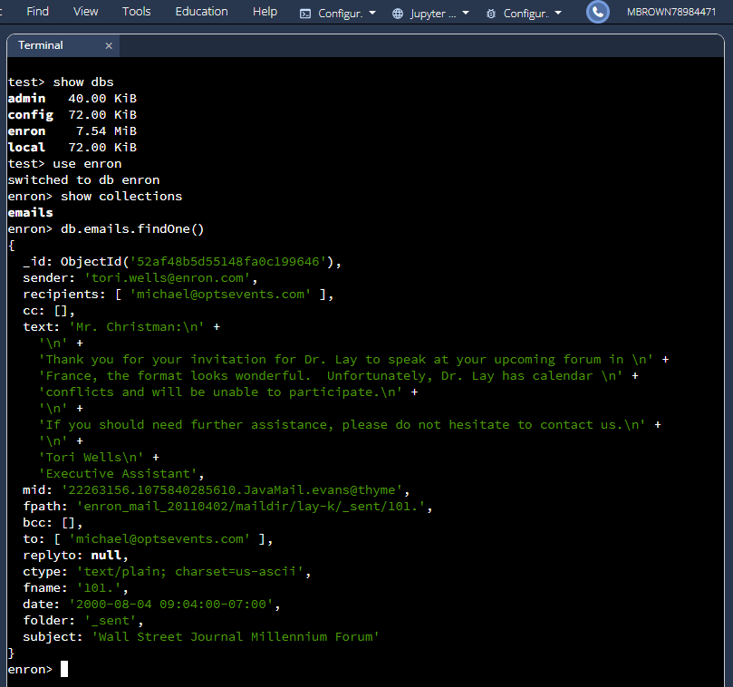

Mongo Shell Commands: Find Size of Single Document 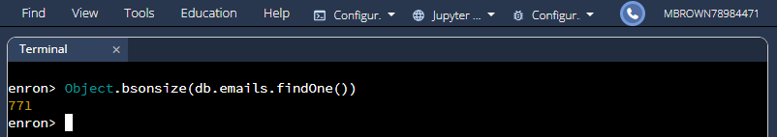
Mongo Shell Commands: Find Size of Collection of Documents
